SEKAI PORT VISUAL OPERATING MANUAL
  - Follow the factory floor. Know where you are, what must move, and where the output goes next.
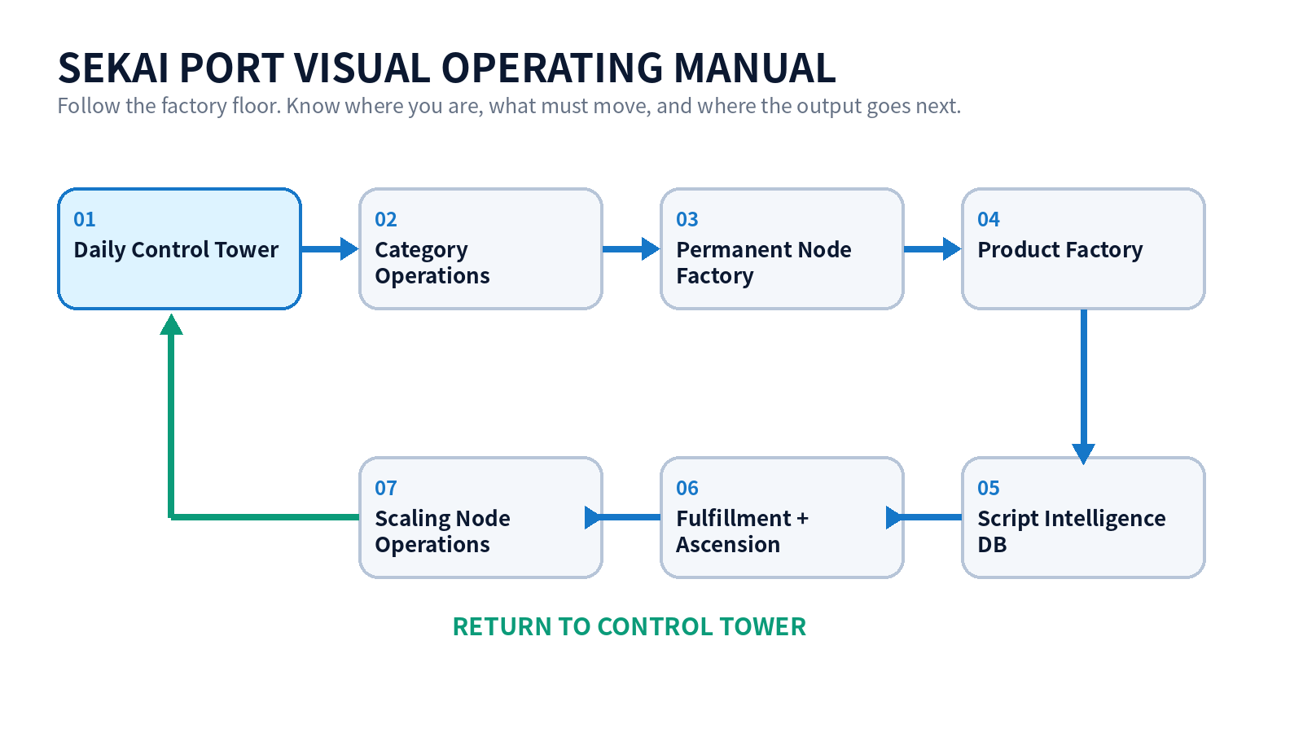

How to use this manual
- Open the Control Tower first.
- Find the constraint.
- Turn to that floor page.
- Complete the exit gate.
- Return to the Control Tower.

01 Daily Control Tower
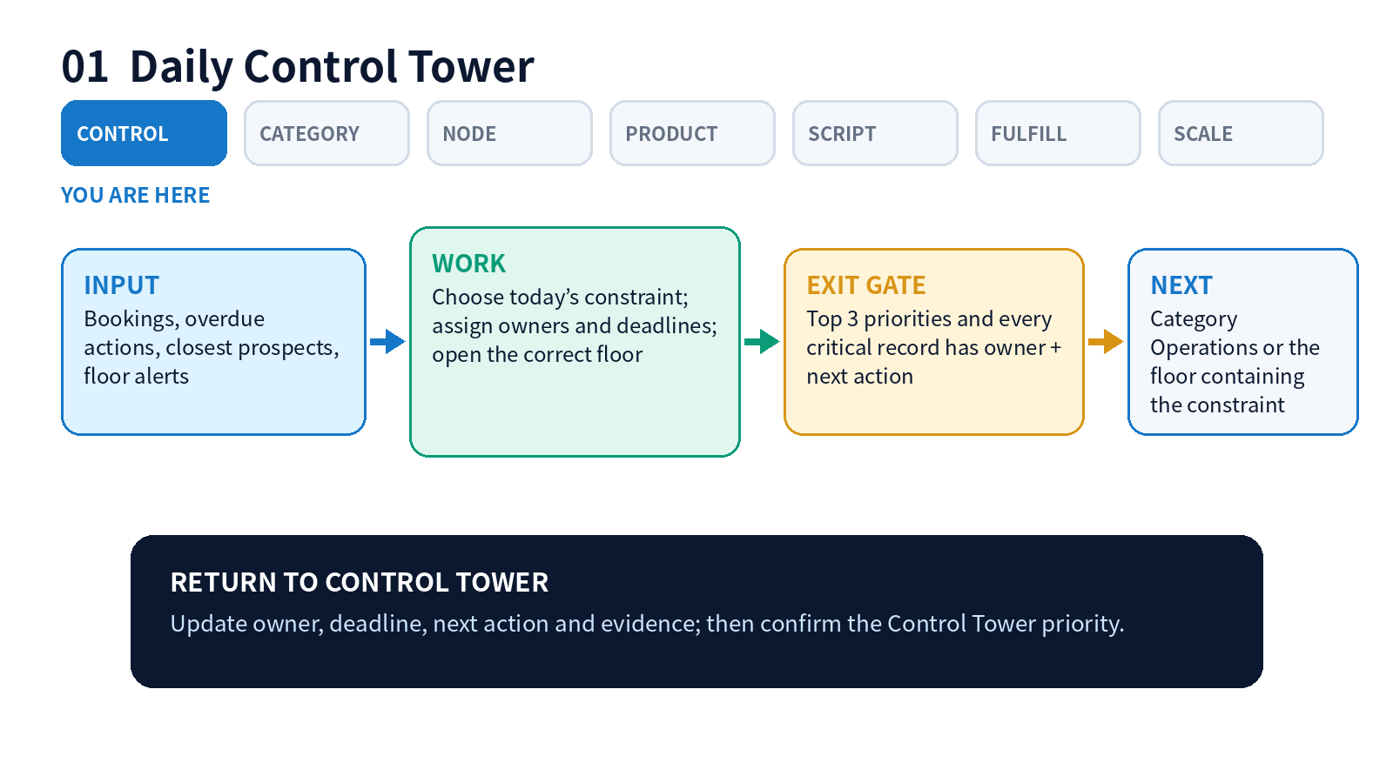

OPERATE THIS FLOOR
- Open Control Tower first
- Review bookings, overdue items and closest five prospects
- Choose one constraint
- Enter the specialist floor
- Return and confirm tomorrow’s top three
Completion check | Handoff
Top 3 priorities and every critical record has owner + next action | Category Operations or the floor containing the constraint

02 Category Operations
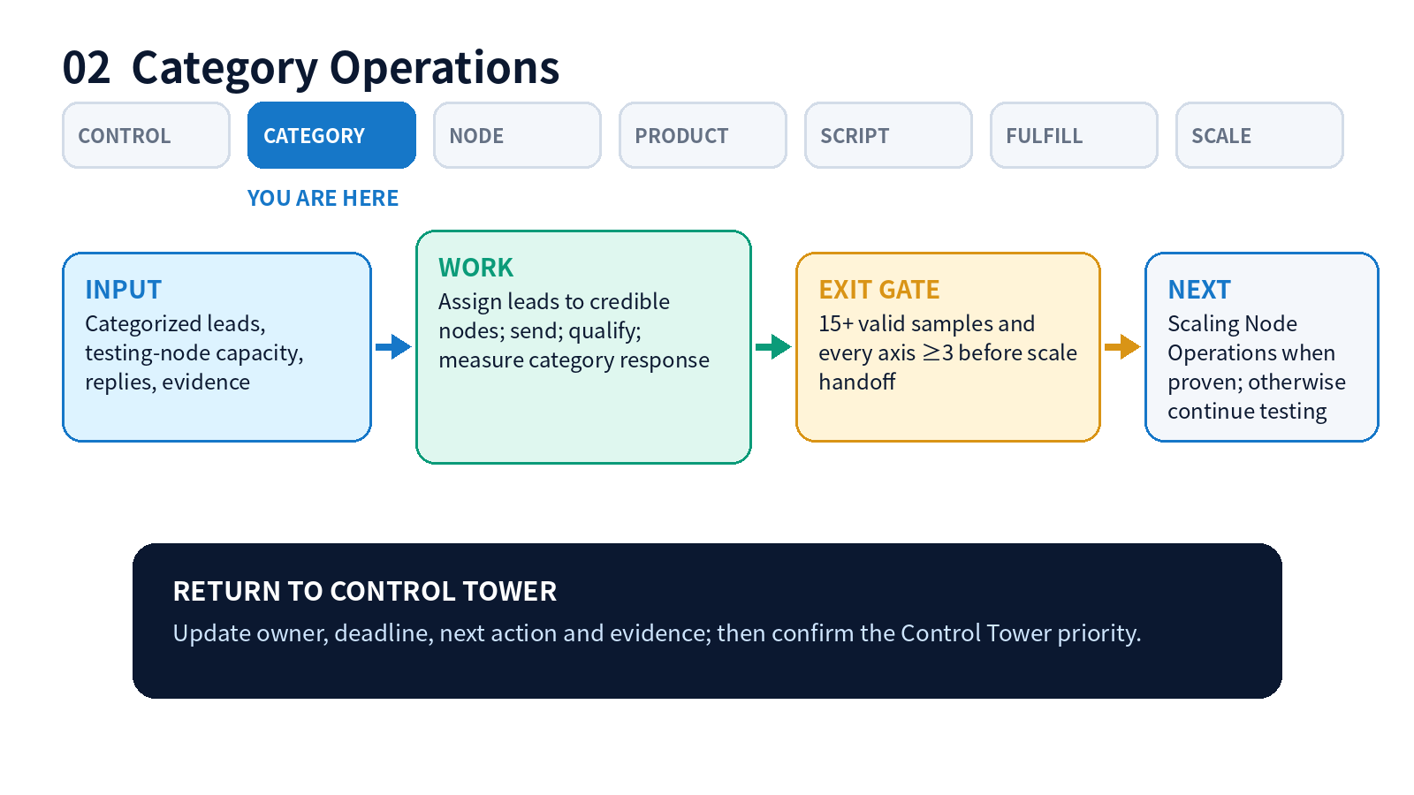

OPERATE THIS FLOOR
- Maintain two days of lead inventory
- Assign by credibility and available capacity
- Record actual reply and qualification
- Promote only after the 15/20 gate
- Create a scale handoff with evidence
Completion check | Handoff
15+ valid samples and every axis ≥3 before scale handoff | Scaling Node Operations when proven; otherwise continue testing

03 Permanent Node Factory
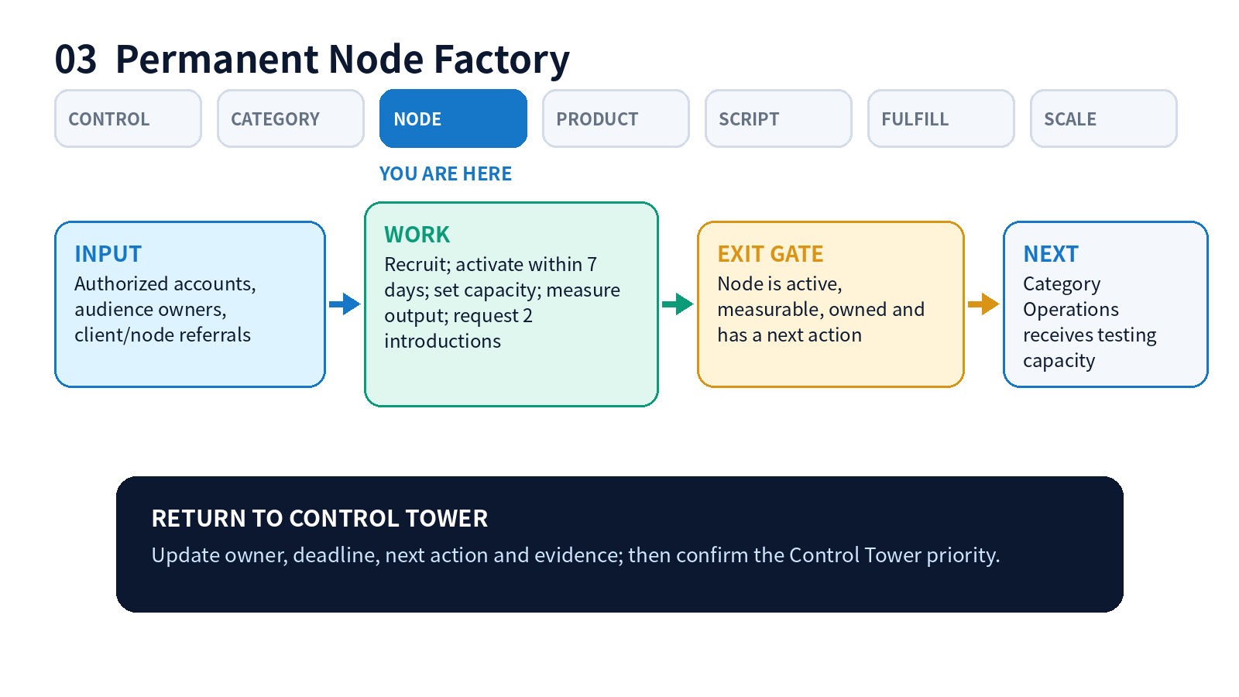

OPERATE THIS FLOOR
- Add test-node candidates continuously
- Activate accepted nodes inside seven days
- Set real daily capacity
- Measure output, not titles
- Request two introductions before activation is complete
Completion check | Handoff
Node is active, measurable, owned and has a next action | Category Operations receives testing capacity

04 Product Factory
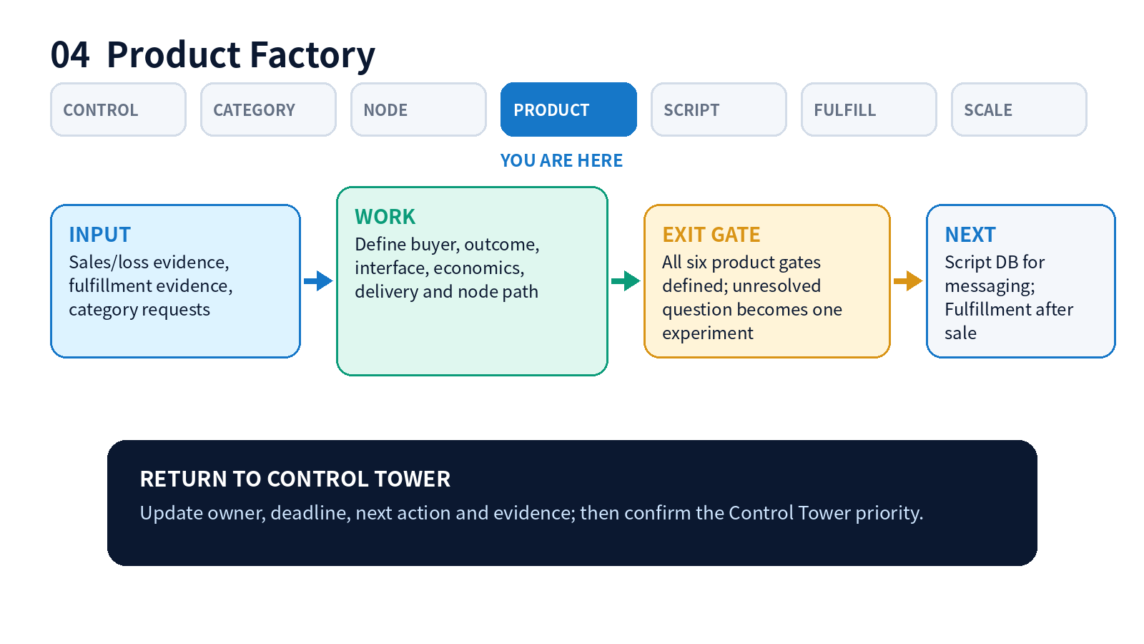

OPERATE THIS FLOOR
- Review sales, loss and delivery evidence
- Check six product gates
- Choose one unresolved constraint
- Create one measurable experiment
- Update only the affected version
Completion check | Handoff
All six product gates defined; unresolved question becomes one experiment | Script DB for messaging; Fulfillment after sale

05 Script Intelligence DB
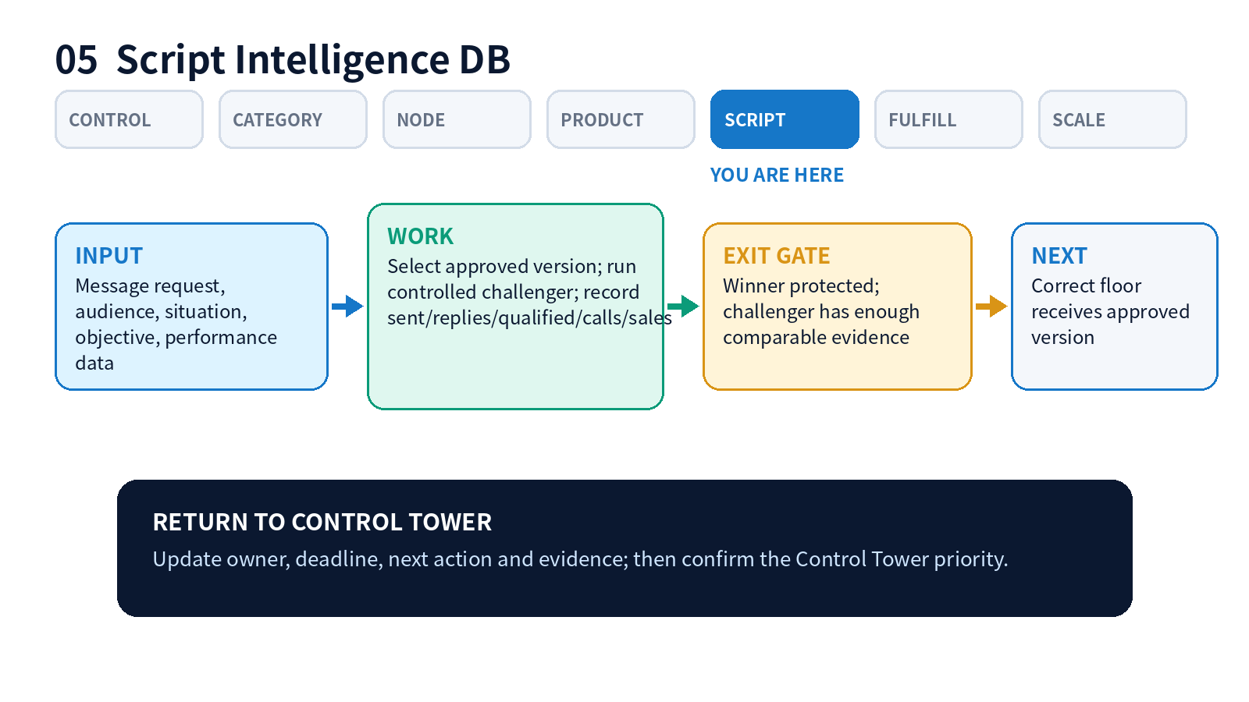

OPERATE THIS FLOOR
- Pull the currently approved script
- Keep audience and objective fixed
- Measure the complete funnel
- Never overwrite the winner
- Promote, iterate or archive
Completion check | Handoff
Winner protected; challenger has enough comparable evidence | Correct floor receives approved version

06 Fulfillment + Ascension
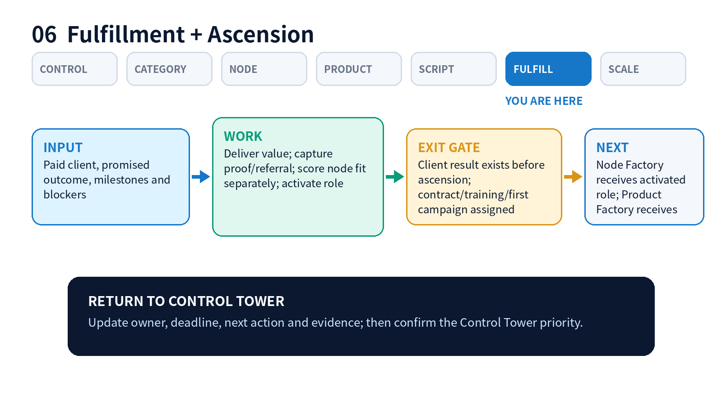

OPERATE THIS FLOOR
- Move every paid client one milestone
- Remove blockers
- Capture proof and referral permission
- Score buyer fit and node fit separately
- Activate only after value and trust exist
Completion check | Handoff
Client result exists before ascension; contract/training/first campaign assigned | Node Factory receives activated role; Product Factory receives evidence

07 Scaling Node Operations
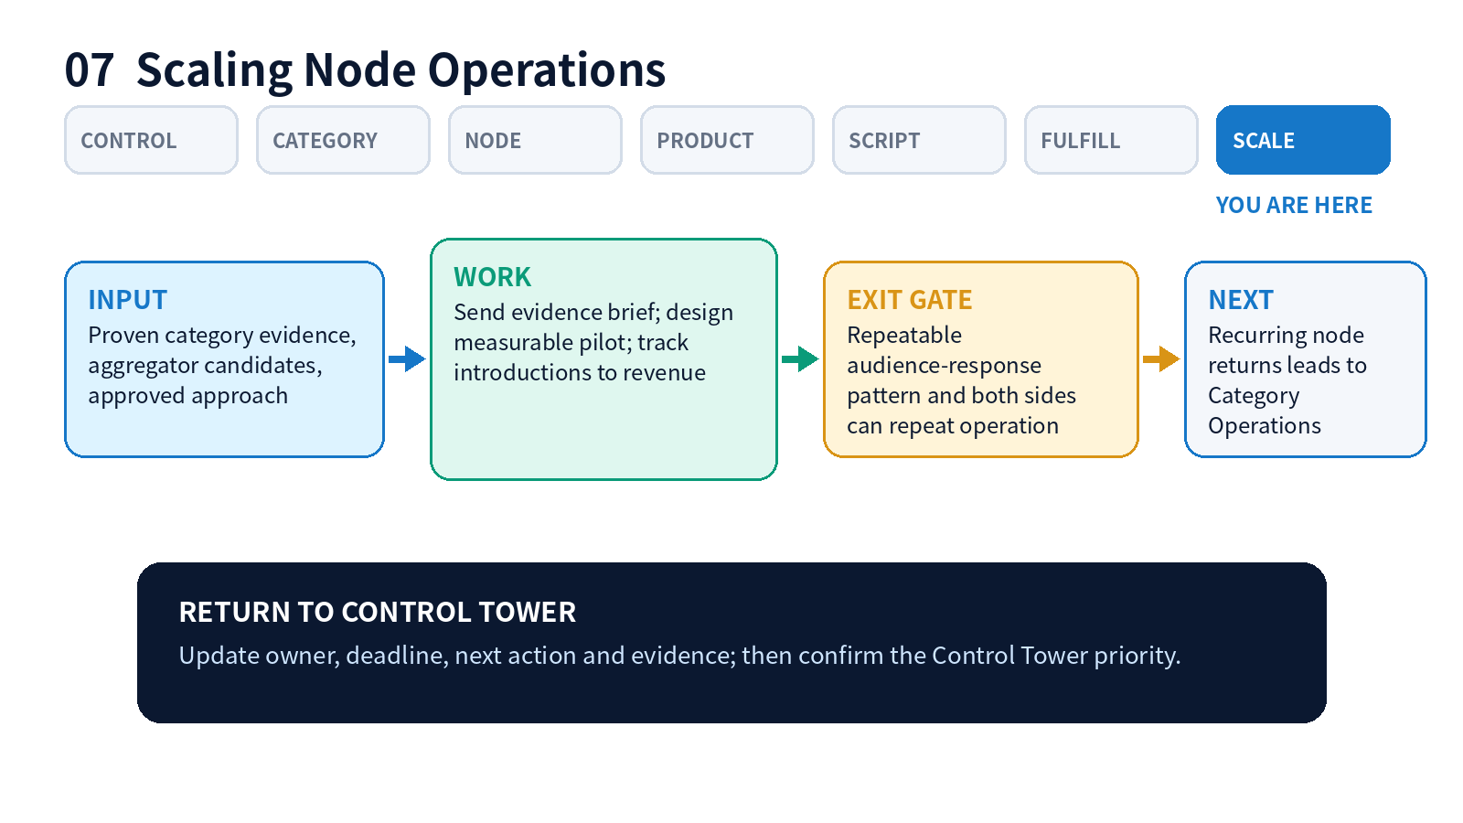

OPERATE THIS FLOOR
- Use proof, not theory
- Approach five candidates per proven category
- Define audience, CTA, owner, date and tracking
- Run one low-risk pilot
- Make recurring only when repeatable
Completion check | Handoff
Repeatable audience-response pattern and both sides can repeat operation | Recurring node returns leads to Category Operations

Daily route: how to walk the factory
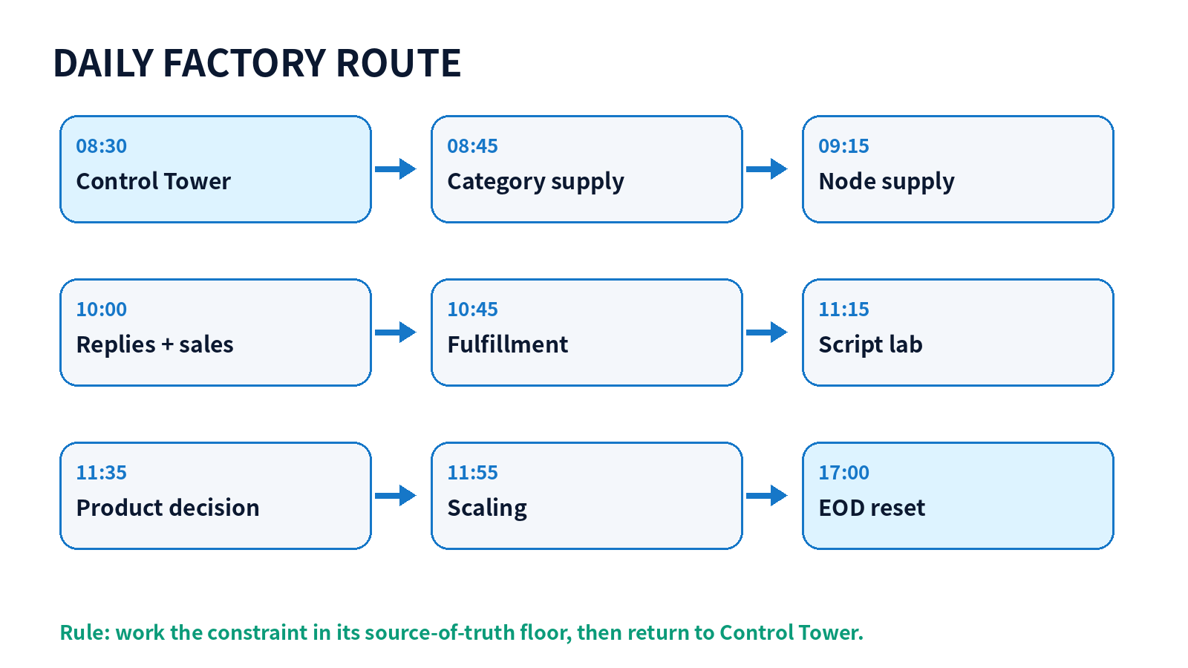

End-of-day gate
- Every critical record has owner, deadline and next action.
- Actual evidence is recorded in the source-of-truth floor.
- Backups are exported.
- Tomorrow’s top three constraints are visible in Control Tower.

